CISCO ATE CAPSTONE PROJECT – Dt 29th Feb 2024
Name: Gayatri Mishra
Email: gayatri.mishra@testdomain.com
Github url : https://github.com/c11472/GITCOMMANDS_DOCUMENT1.git

Introduction :
Automation using Selenium , Java & Junit or TestNG ..

Framework Template :

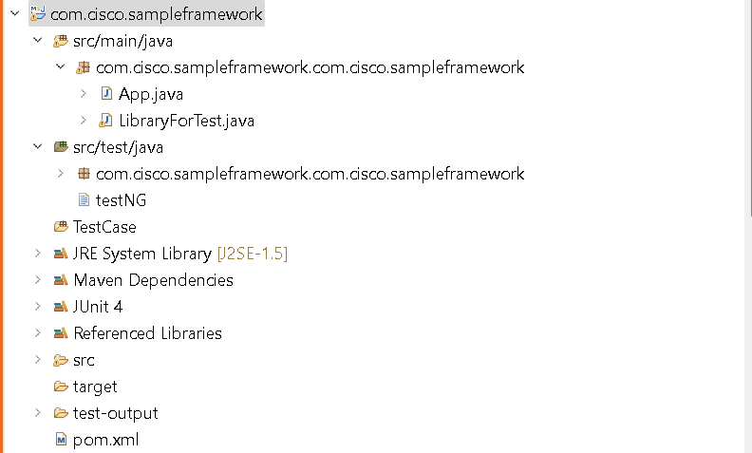

How to execute :
- Import the project in eclipse IDE
- Identify testNG.xml
- Run testNG.xml

Reports :
Emailable report.html
// provide the screenshot for emailablereport.html

Reason for failure of the test :
NA if you do not have any failed test.

Console reports
// provide the screenshot for console report

Run the job using Jenkins:
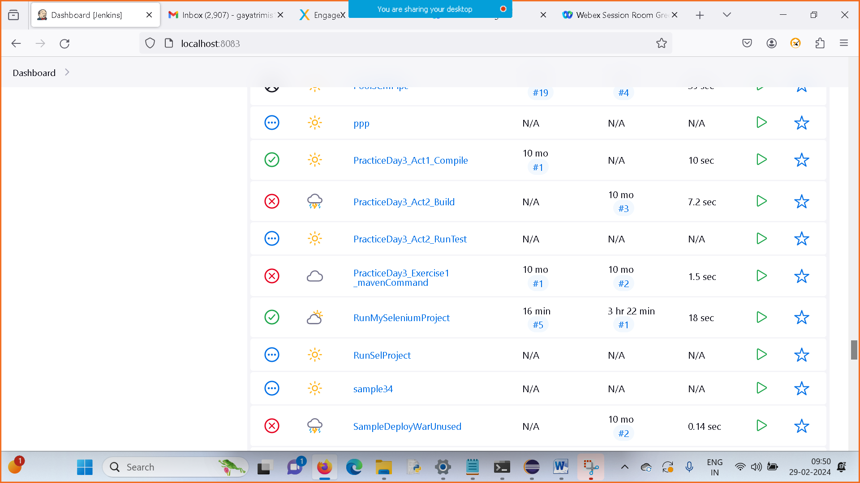
The job – Runmyseleniumproject

Build the job :
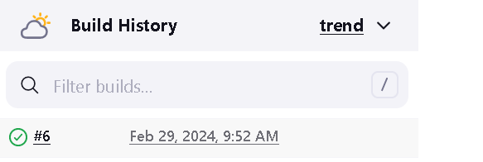

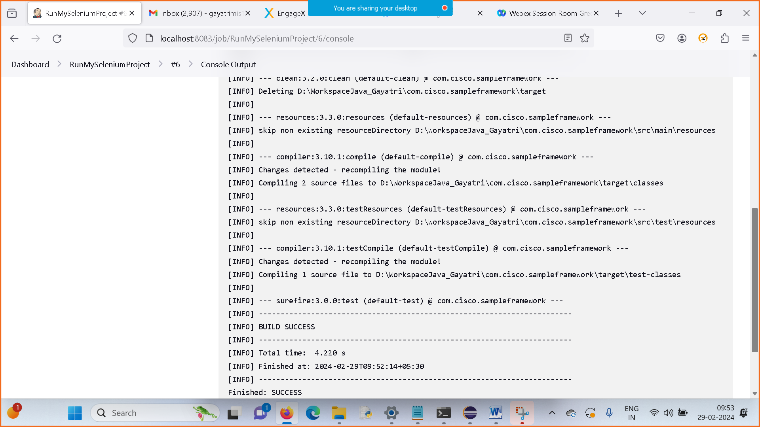

Part – 2:
Jmeter Deliverables
Step wise provide the screenshots from ThreadGroup creation till execution logs

